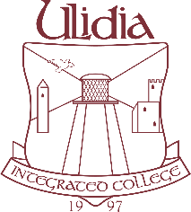

August 2017

Dear Parent

Voluntary Donation to Family Fund 2017 – 2018

The Family Fund was established by the Parents and Governors of Ulidia Integrated College, Carrickfergus, to help the college provide for the educational needs of our pupils that cannot be met from our normal funding.

It is a voluntary donation to the college and can be made in a number of ways. As a registered charity, we may be able to claim tax back on any donations received so your donation will be worth even more to the college. Please make sure you leave the Gift Aid box ticked on the payment section of ParentMail.

The fund is vital to support the day to day running of the school and all children benefit from it. It can be used in a variety of ways such as paying for additional transport costs, subsidising educational visits and fieldtrips, Information Technology, books, rewards for example.

In today’s educational budgets, schools are facing more and more financial challenges and any help you can offer us is deeply appreciated.

Each family in the college, regardless of the number of students from that family attending the college, is asked to donate £60.00 per year. This can be paid in any amount per term that you feel you can afford.

If you feel able to donate to this fund, payment can be made online by ParentMail or by cash or cheque.

I would like to emphasise once again how important this fund is for the college and how grateful I am for your support.

Yours sincerely

M Houston
Principal

