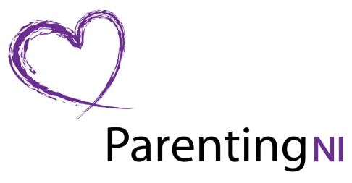
Booking Form
Each person requiring a place must fill out a separate form (photocopies accepted)
Celebrating & Supporting Parents in Northern Ireland
“Why won’t my teenager talk to me?”
Dr John Coleman OBE, Senior Research Fellow, Department of Education, University of Oxford
Thursday 5th June 2014
6:30pm – 8:30pm
Registration & Refreshments from 6:00pm
Belfast City Hall

NAME
POSITION
ORGANISATION
ADDRESS

POSTCODE
DAYTIME PHONE NUMBER
EMAIL

For further information please contact Sharon McWhirter on 028 9031 0891 or
e-mail: sharon@parentingni.org

