CLC

Carrickfergus Learning
Community

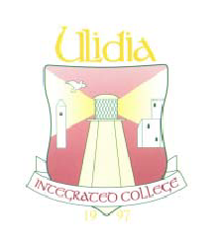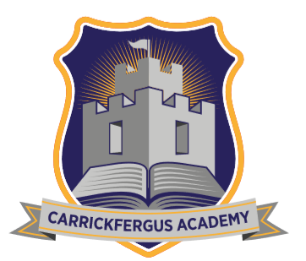

Three Schools – Equal but Different

STUDENT INDUCTION HANDBOOK
September 2024

Introduction
Congratulations on your GCSE examination success and we welcome you into the Carrickfergus Learning Community.
Carrickfergus Learning Community came into being in response to the Government recommendation that all schools should offer a range of 27 Post 16 subjects to 6th form students. Economically it would be difficult for any one school to comply with this aspiration; hence the three Post Primary Schools in the town of Carrickfergus have pooled resources and expertise and are now able to offer a wide range of subjects. Our experience of collaboration is now well established and the benefits for CLC students as they complete their post-16 studies proven.
Since 2006 more than one thousand students have accessed courses that would have previously been unavailable to them. This has allowed them to better prepare for further education and employment in their chosen career paths.
The greatest benefit of CLC for students, is a broader range of choice in courses and qualifications. There are the other advantages including an increased social mix, stimulation in a new and different environment, different teachers and increased independence. These experiences are of great value to a maturing young adult.
This Induction Booklet has been designed to help you understand the workings of CLC on a daily basis. There will be an opportunity to visit your host school to meet key staff and find out more about what to expect in studies and how to fit in to the school environment.
Keep this booklet in a safe place so that you can refer to it as and when you need.
You will find photographs and names of CLC Coordinators and contact numbers for each school at the back of this booklet.

Induction (– a three stage process for students, parents and teachers)
Students
On Wednesday 28th August at 2.00pm you will travel to the school you will study in, by taxi or walking, and have an opportunity to meet staff involved with the CLC. You will also learn the geography of your host school including where and how to sign in and the location of classrooms and toilets. This should all serve to help you feel comfortable in your host school.
Parents
Your home school will send you a CLC Parents Information Video link which will provide you with an introduction to the day to day workings of the CLC, the roles and responsibilities of everyone involved and an opportunity to meet key staff involved and how they may support your son/daughter in their studies. It will also give you the opportunity to ask the Co-ordinators any questions you may have regarding your son / daughter studying a subject in another school. This on-line event will be held on Wednesday 28th August at 7.00pm

Integration and welcoming activities will take place at the first formal meeting of each class so students and staff can get to know each other. CLC classes will commence on Monday 2nd September 2024.

Contract
You and your parents will be expected to sign a contract before you start your CLC classes. This is intended to clarify our expectations and standards. Please read this carefully to make sure you understand your commitment. An extra copy of the contract is in this booklet for reference, a signed copy will remain in the school. It is of the utmost importance that parents take every opportunity to be involved in the process by accessing all parental information provided and attending consultation events in both the home school and host school.

Student Information Sheet
In the event of an emergency it is important that both your home and host school have up to date contact numbers and medical information. Your information will be kept confidential within each school, but you must appreciate the importance of this being accurately completed. Please complete this form and return to your school CLC Coordinator as soon as possible. If it needs to be changed or updated at any time, please let both schools know the changed details.

Transport
Local taxis are used to carry students between Ulidia Integrated College, Carrickfergus Grammar School and Carrickfergus Academy. It is very important for the smooth operation of CLC classes that the transport system works well. In this respect pupils need to:
- Go directly to their pick-up point at the arranged time
- Make every effort to maintain good, courteous relations with the taxi staff
For classes starting at the beginning of the school day it is each student’s responsibility to get to their host school on time. A taxi will return from your host school at 11:05am. For the middle session a taxi will take you to your host school at 11:20am and return you, at 12:35pm, for lunch at your home school. The taxi for afternoon classes will collect you at 1:15pm but you will be responsible for making your own way home from the host school at the end of the day. You will be given a code for your taxi, make sure you get into the correct one.
Students will walk between Carrickfergus Grammar School and Carrickfergus Academy.
Please note that students are only permitted to drive in their own cars once they have completed and returned the CLC Driving Contract and any deviation from the normal taxi run arrangements must be referred to the CLC Co-ordinator in your home school. Students who drive in their own car are not permitted, in any circumstances, to carry any other passengers.

Parents
Reports will be issued to Parents as usual from the pupil’s home school but in addition to that they will receive at least one annual report from the host school.
In addition to reports from both schools, parents will be invited to attend Parent Interview sessions in both schools. It is important that your parents understand your progress so that they can support you in your studies. It is therefore of the utmost importance that parents attend these interviews and support their son/daughter at this challenging time in their educational development.

Examinations
Many examination dates and times are beyond the control of schools and so at exam time the schools work closely together to ensure smooth timetabling and planning transport outside ‘normal’ routine of CLC classes. External examinations will be sat in your host school however exam results will be provided in your home school.
To prepare students for examination revision classes are arranged during study leave. Students must attend these classes and full uniform should be worn on these occasions as on all other occasions.

Coursework
While this is the responsibility of the host school to set and mark, should any problems occur these will be addressed through the CLC Coordinators in each school.
As with other A-level subjects, deadlines and dates will be given which must be adhered to. You should get the submission and exam dates at the beginning of the year and these should be noted on a calendar at home. Setting reminders on your phone or e-mail would be a sensible strategy.

Teacher Contact
Maintaining contact with teachers in your host school can be difficult. You will not be able to ‘drop in’ with your teacher during a free period to clarify a homework question or coursework issue. Therefore, you must work out strategies which will work for you and your teachers. Use of the school e-mail system and google classroom to seek study support and guidance is one strategy that can be used. This can be useful experience as many universities and employers use this method of communication.
Where parents need to make contact, they should do so through the School Co-ordinator – details appear on the final page of this booklet.

Absence
If you are ill or are absent for any reason, you must contact your own school so that the coordinator can get in touch with your CLC teacher. As you have less opportunity for informal contact with your teacher attendance at class is crucial. Please note that your contract states you will attend at least 95% of classes or your place on the CLC course may be put in jeopardy.

Holidays
Enclosed with this booklet is a holiday list showing the holidays of all three schools. As a CLC student you will be expected to attend classes in your host school even if your own school is closed but your host school is open. If your host school is closed, and your own school open, you will be expected to join a private study group in your own school.

School Coordinator
The coordinators in each school keep in regular contact; if you have a problem or difficulty you must inform the coordinator either in your host school or your own school. They will try to resolve the problem. Please make use of this resource when needed!

Use of Host School
Remember that you are a student guest attending for lessons and that not all facilities may be available to you. Make sure that you find out where you can go and where not!
CLC – AGREED STANDARDS FOR QUALITY
ASSURANCE OF TEACHING AND LEARNING

The Carrickfergus Learning Community aims to promote the highest standards of teaching and learning amongst all of its teachers and pupils. This document sets out to highlight the agreed standards we strive to uphold at all times.

AIMS OF THE STANDARDS SET
- To allow students to develop a positive approach to lifelong learning.
- To support students in achieving their full potential and making informed and responsible decisions in preparation for adult and working life.
- To extend the offer of subjects to students within the CLC.
- To work collaboratively to enhance the learning opportunities for young people within CLC.
- To use flexible teaching styles and methods which will best suit the needs of learners.
- To provide appropriate academic and pastoral support for students.

LEARNING STANDARDS
- Pupils will be accountable for their attendance at classes.
- When communicating by email pupils and teachers will use only C2K email.
- Pupils will act in an independent manner.
- Appropriate learning styles will be catered for by teachers.

TEACHING STANDARDS
- Teachers will use of a range of teaching strategies.
- Lessons will be appropriately paced.
- Feedback will be provided in an appropriate manner.
- Lessons will start and finish purposefully.
- The room will be neat/tidy/well organised and feature displays of pupil work.
- Pupils, parents and teachers will have high but realistic expectations.
- Extra help will be offered within reason.
- Where action is needed and remedial help is to be offered this should be done as soon as it is feasible to do so.
- Positive language will be used with pupils.
- Appropriate lessons will be prepared and well resourced, making use of a range of questioning techniques.
- Learning intentions will be introduced at the start of a lesson and reviewed at the end of the same lessons.

ASSESSMENT/REPORTING STANDARDS
- Homework will be a follow on from the lesson or prepare the pupil for future work.
- Homework will be set / marked regularly with comments designed to help pupils improve their work.
- Parents’ evenings will offer the opportunity for feedback on student progress. Invitations will be issued by the Host School.

PASTORAL AND DISCIPLINE STANDARDS
- Good working relationships between staff and pupils will be established and maintained.
- Pupils will learn in a pleasant, calm, caring, supportive, relaxed and positive environment.
- Positive parental input will be vital to support pupil progress.
- Pupils will email staff to get caught up if they are absent.
- Any application of discipline will be fair and proportional to the misdemeanour.

Carrickfergus Learning Community

Procedures for teachers with a concern about a visiting student:

Host School
Classroom Teacher

Host
School
Coordinator

Home
School
Coordinator

If concern is child protection / child in need related?
If concern is work / behaviour related

Home School Designated Coordinator for Child Protection

Home School Head of Year /
VP / Principal

Home School Child Protection Procedures followed
Home school Head of Year / VP / Principal reports course of action to Home school coordinator to relay feedback to host school

Carrickfergus Learning Community

Procedures for pupils / parents who have a concern about a member of staff from a CLC Partner School

A pupil / parent has raised a concern about a member of staff in a CLC host school

Pupil / parent reports to home school Co-ordinator

Home school Coordinator reports to home school Principal

Home school Principal discusses with Host Principal

Host school Principal may discuss with Host School Co-ordinator
Host School Principal discusses with Vice Principal and action agreed

CLC Student Contract

Student name: CLC Subject: ____

Home School: ________________________CLC School: ____

I agree that I have read, understood and am willing to uphold the terms of the contract for studying within the Carrickfergus Learning Community.
- Maintain excellent attendance – over 95%.
- Make use of class and non-class time to produce the highest standard of work in line with my ability.
- Make use of the taxi service to move from school to school as agreed.
- Arrive in host school on time ready to participate fully in the activities of the class.
- Adhere to the standards of behaviour in the host school.
- Accept the discipline rules of the host school.
- Co-operate fully with the staff in the host school and treat all members of that school community with respect.
- Meet the deadlines set in all areas of study.
- Be a positive role model for other pupils in the school in which I am being taught.
- Attend all tests and examinations related to my course of study.
- Attend all classes even if my own school is closed but my host school is open. This includes early closures, condensed days and during examination (and mock examination) periods.

Tick here:

Please tick to confirm the following:
- I understand that failure to maintain the terms of this contract may result in a sanction or my being asked to leave the subject being studied through the Carrickfergus Learning Community.
- I have watched the narrated induction PowerPoint on the school website.
- I have read the induction booklet and have a copy of the combined schools holiday list. This is also available on the school website.

Student signature Date

CLC students perform better when they receive support from home. It is therefore of the utmost importance that parents are aware of the expectations placed upon students studying within the CLC.

By signing below, you confirm that you and have read all the relevant information provided by staff, attended the parent on-line induction presentation, viewed the narrated powerpoint and will attend consultation events later in the year.

Parent/guardian Date

School Co-ordinator Date _____________

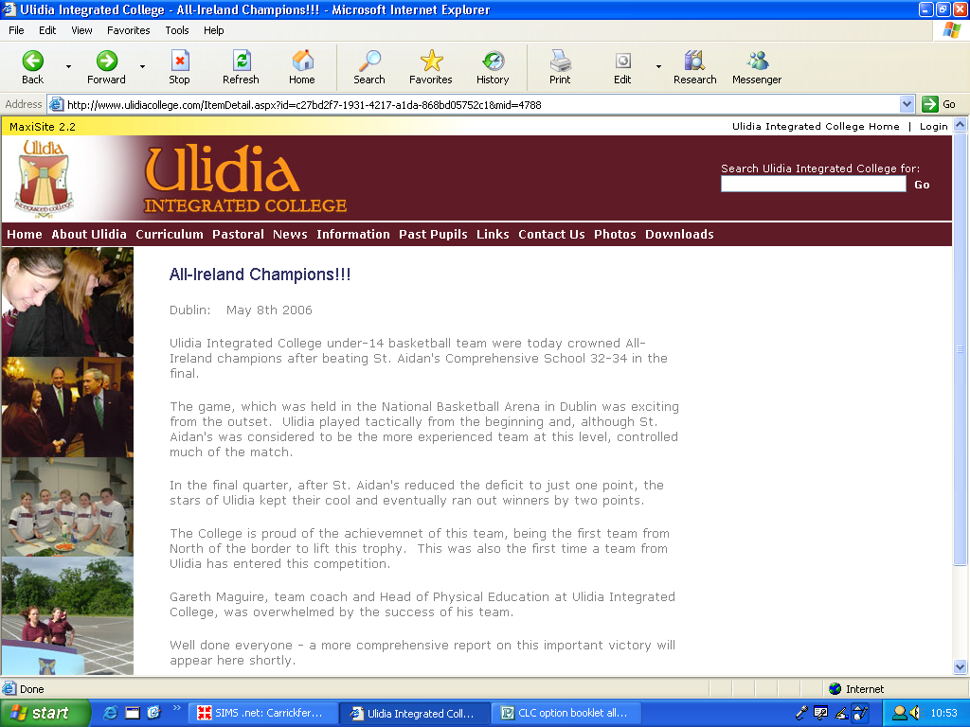
WHAT IS EXPECTED IN A CLC CLASSROOM

FROM TEACHERS:

⇒ Keep accurate attendance records
⇒ Start lessons with learning intentions and finish with a plenary
⇒ Give clear guidance on how to improve work, using data, targets and verbal feedback on work
⇒ Keep in contact with students inside and outside the classroom
⇒ Build positive relationships with students
⇒ Prepare and resource interesting and challenging lessons
⇒ Ask effective questions
⇒ Regularly set and mark homework and tests with comments for improvement
⇒ Have high expectations and communicate those to students
⇒ Demonstrate top grade standard work
⇒ Determine pace of lesson
⇒ Give clear instructions
⇒ Provide positive feedback on work
⇒ Provide extra help when needed
⇒ Communicate with home/ CLC Co-ordinator when necessary (in liaison with home school)
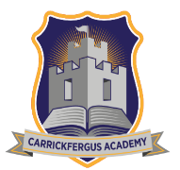

WHAT IS EXPECTED IN A CLC CLASSROOM

FROM STUDENTS:

⇒ Regular attendance and prompt arrival to class – attendance is
expected even if the home school is off or doing examinations
⇒ Proper books, files and equipment brought to class
⇒ Any homework, assignment work or research done as requested and
on time
⇒ Take responsibility for catching up on any work missed due to
absence
⇒ Act on teacher’s advice for improvement
⇒ Regular contact kept with teacher inside and outside classroom
⇒ Ask questions if more information/clarification is needed
⇒ Answer questions to the best of ability
⇒ Listen to the answers given to other students’ questions
⇒ Engage fully and positively in lessons – with teacher and classmates
⇒ Seek to build a positive relationship with teacher and classmates
⇒ Engage in independent study/reading as expected for “A” level
⇒ Make a determined commitment to achieving full potential
⇒ Follow rules and expectations of HOST school when you are
attending there

Contact details

If you are going to be absent you should inform your CLC Co-ordinator and/or your host school if you know in advance. If you are in receipt of EMA we need an accurate record of attendance, so you must take care to keep us informed.

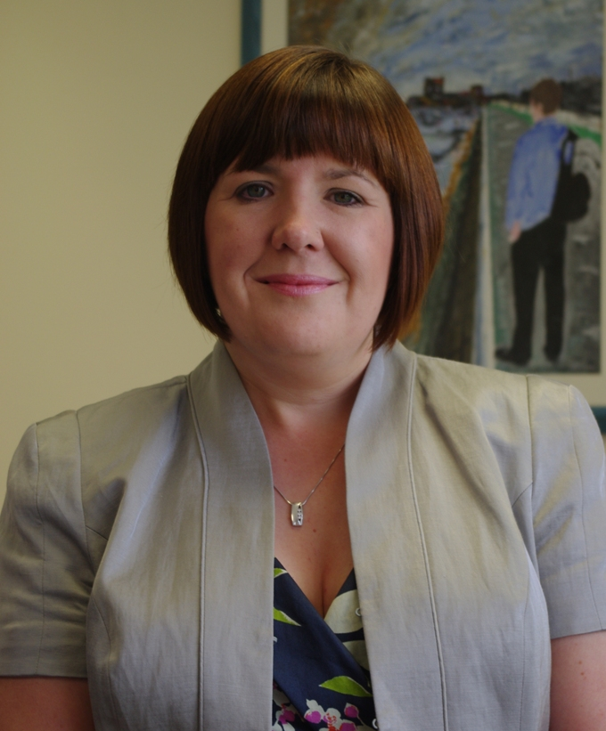

Mrs McClean 02893362347
Carrickfergus Academy
e-mail jmcclean684@c2kni.net

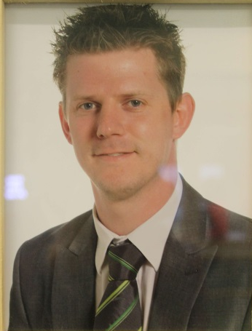

Mr Dunlop 02893358500
Ulidia Integrated College
e-mail bdunlop171@c2kni.net



Mr Martin 02893363615
Carrickfergus Grammar School
e-mail smartin782@c2kni.net

